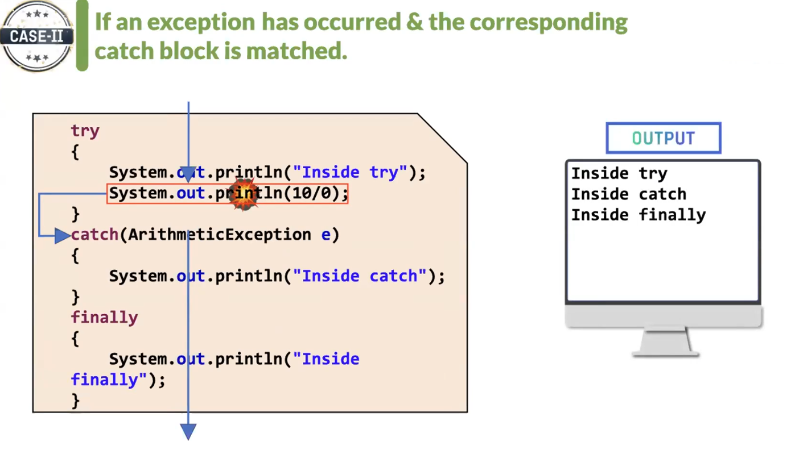

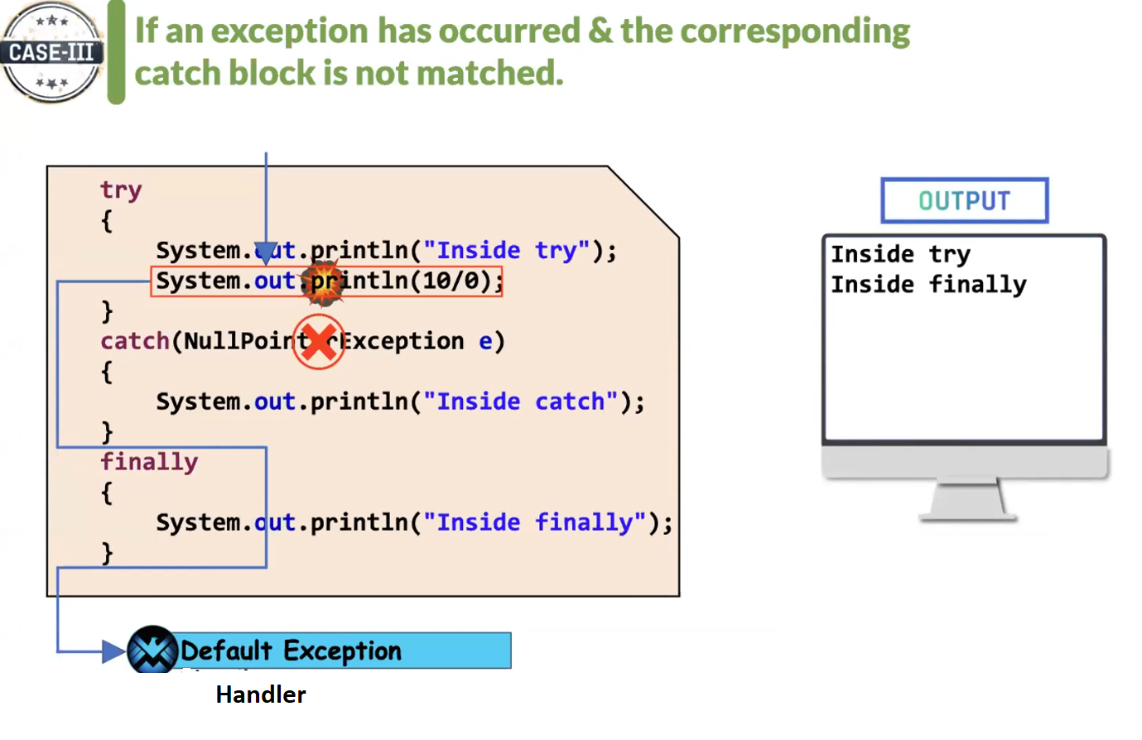

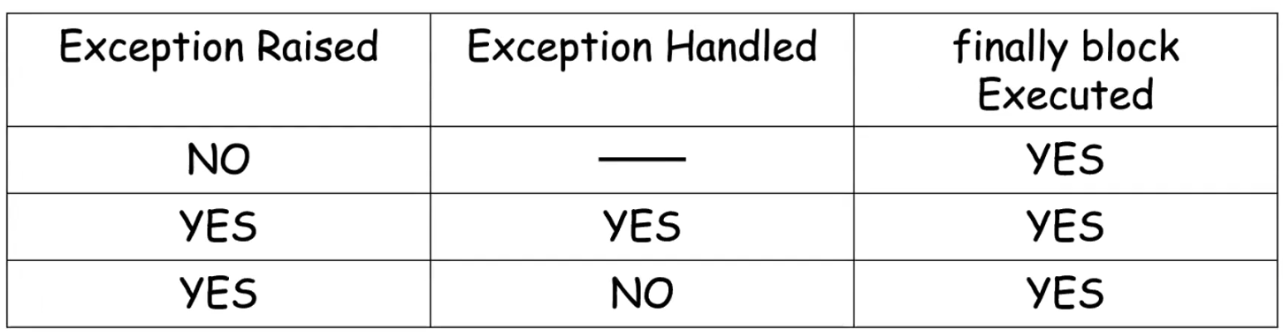

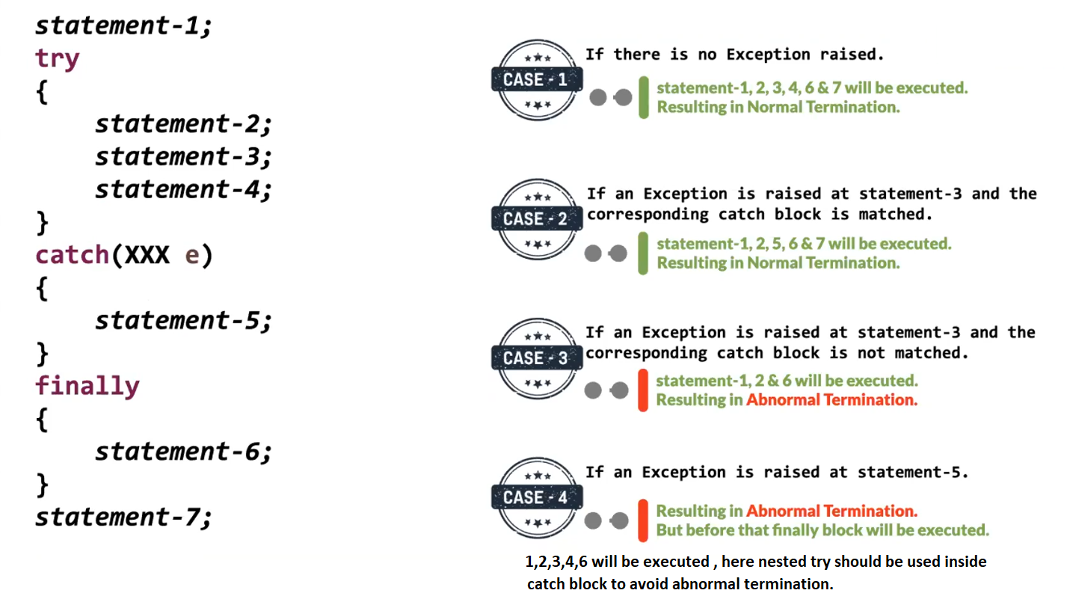

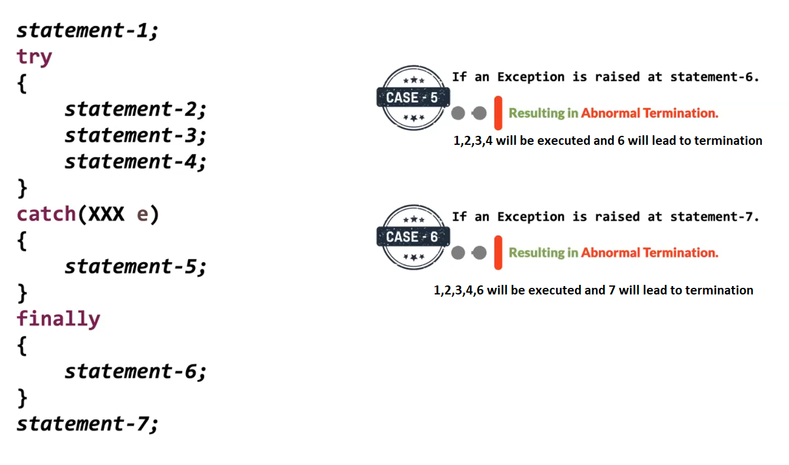

All the classes of exception are present in java.lang package

Partially checked exception :

It is such a parent Exception class where its child consists of both checked and unchecked exception classes .

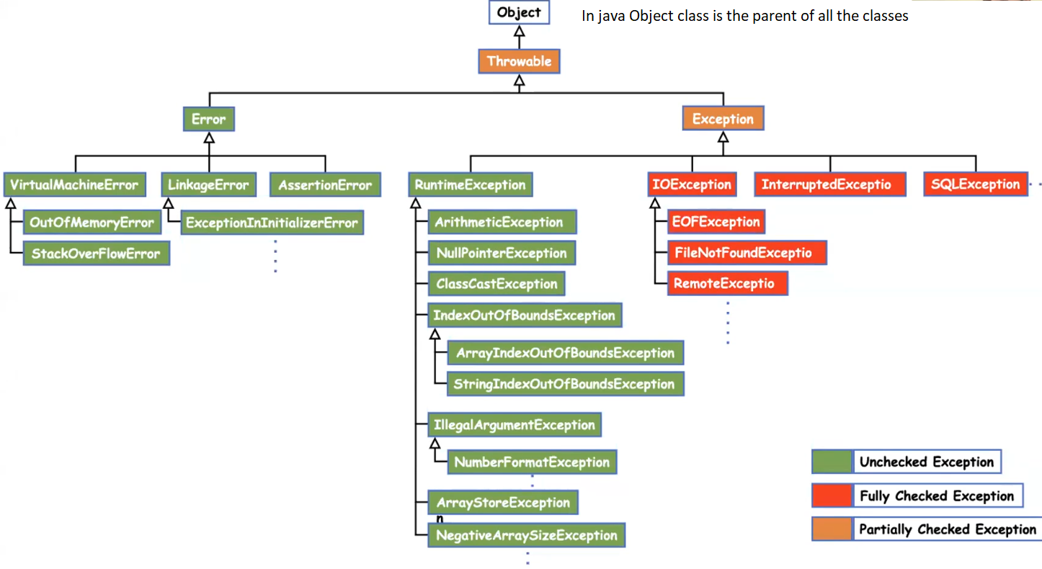

Nested try-catch example

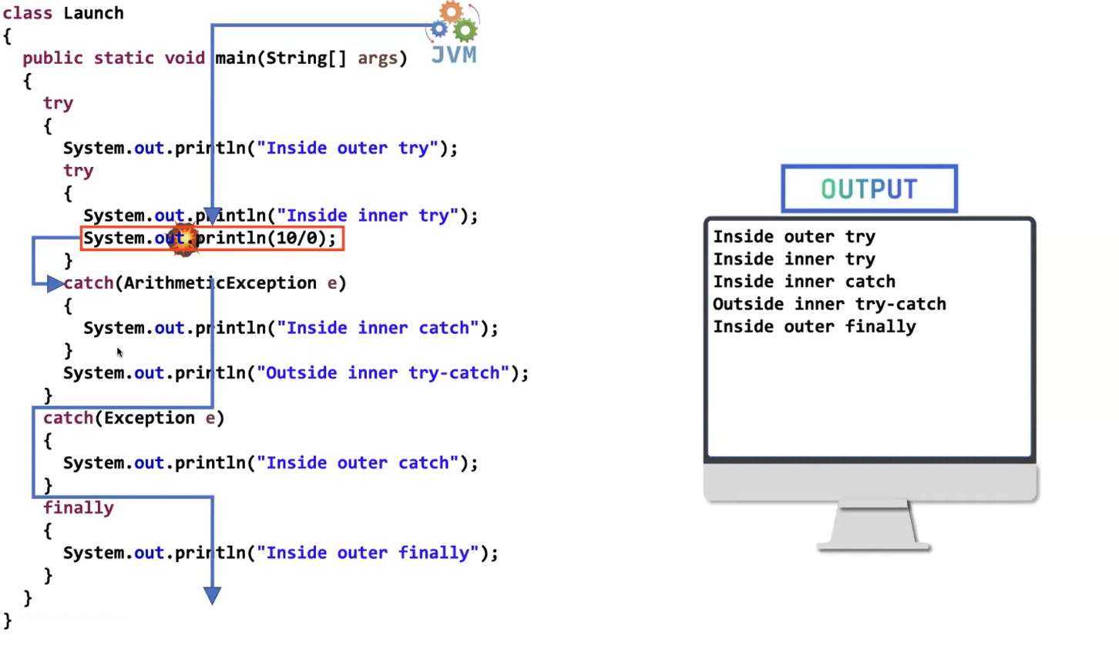

We can write another try-catch in “inside inner try” .

Similarly we can write another try catch in “ inside inner catch” .

Even in the finally block also we can write try-catch.

We can write any number of times nested try - catch there is no restriction.

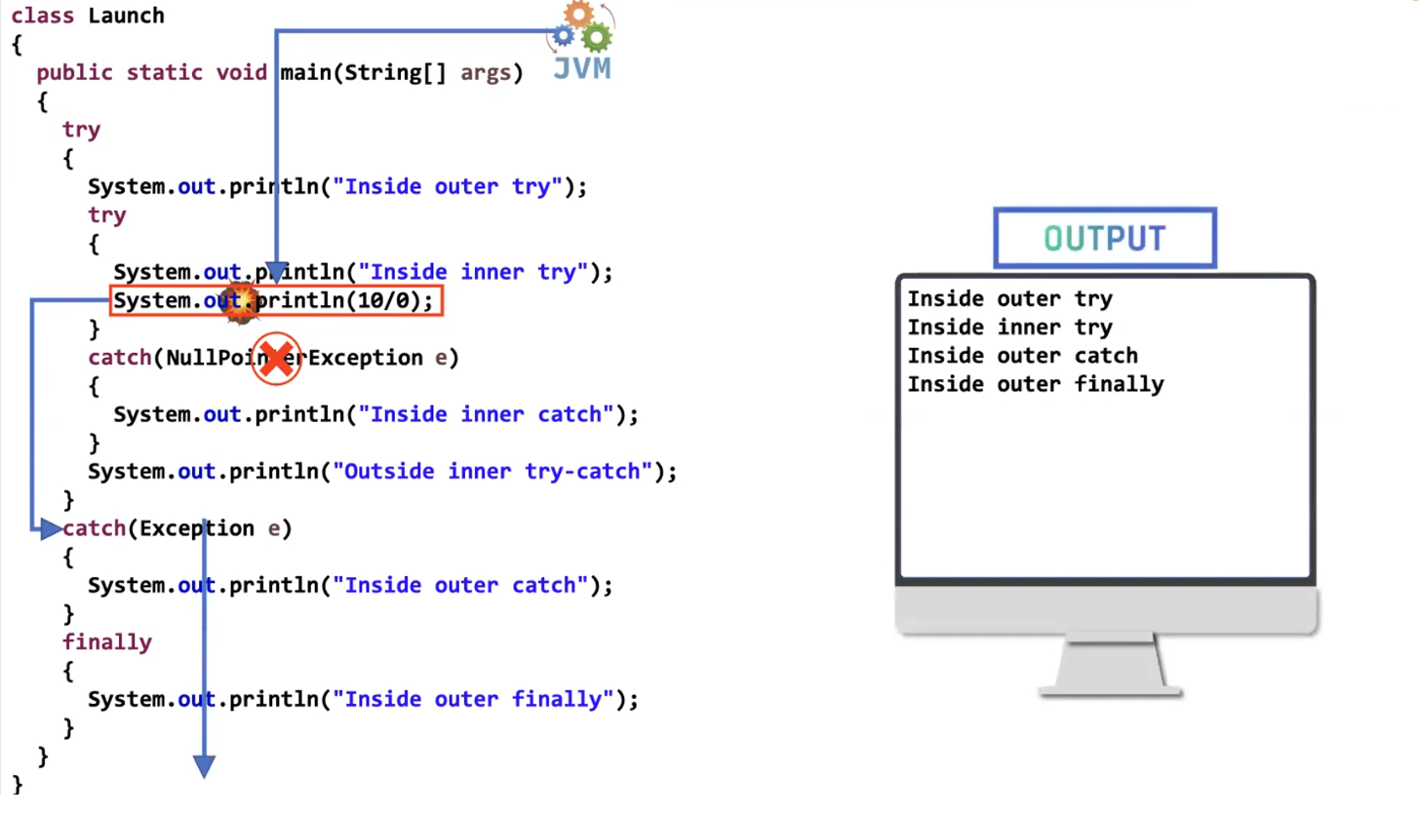

If inner catch block doesn’t handle the exception , it can be handled by the outer one . if outer catch also cannot handle then default exception handler comes into picture .

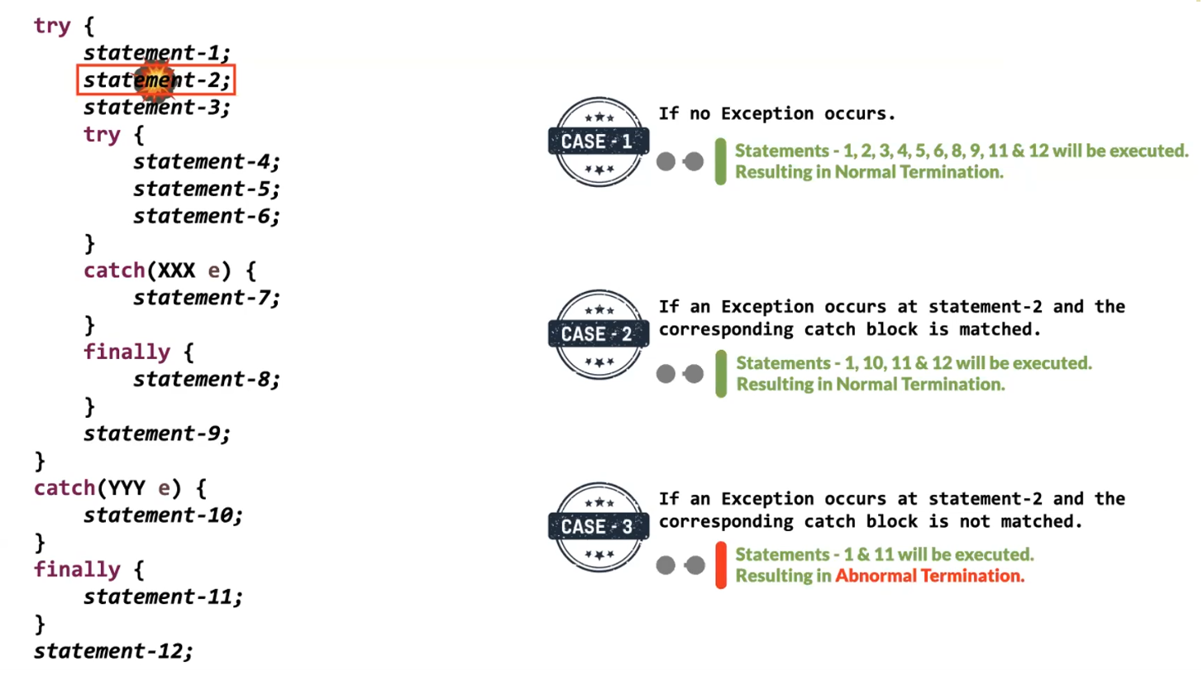

Here in case -2 exception arised in statement-2 , so inbetween code from where the exception arised and catch block starts ( if exception is matching) will not be executed , even though the inbetween code consists of nested try-catch blocks . and code after catch block will be executed.

Note : finally block will be executed every time irrespective if exception arised (or) not , handled (or) not.

Similarly in case -3 if exception is arised and not handled code before exception is executed. And code after the exception will not be executed , even if there are nested try catch blocks after the exception arised line.

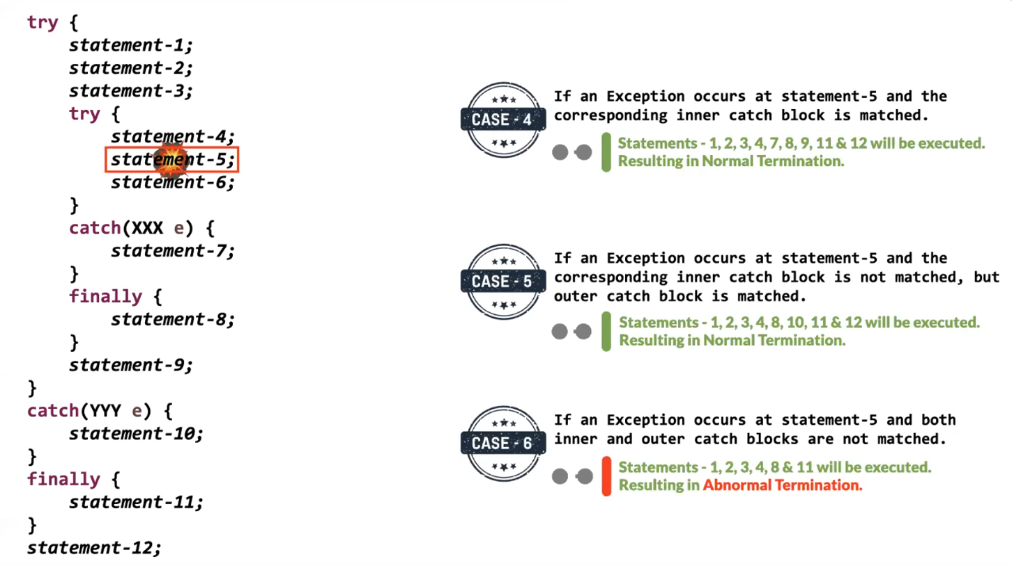

Eg: Exceptional_Handling_Case_7

// go through the code

Eg: Excaptional_Handling_Case_8

// go through the code

Possible allowed syntax for try – catch, finally block.

